**Koni Steffan AWS Site visit**

9th November 2013

Rosey Grant, Petra Mildeova, Jon Bowland, Tommo Shergold, Alan Davies

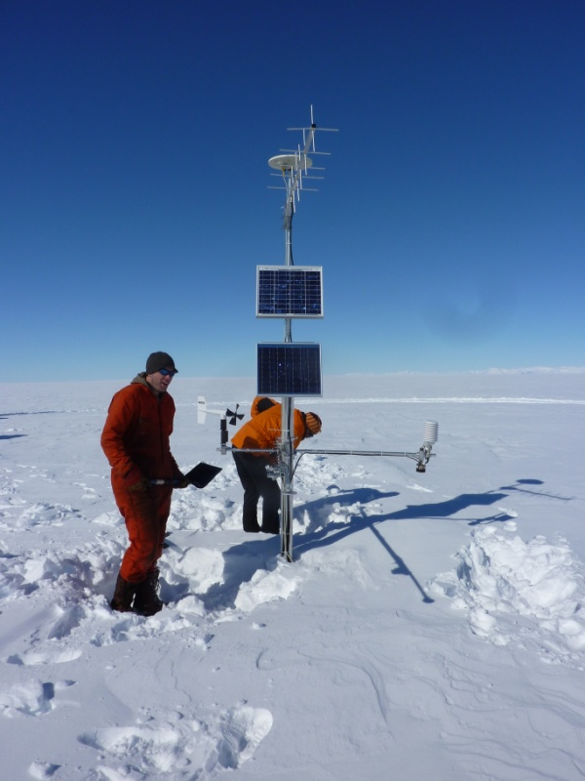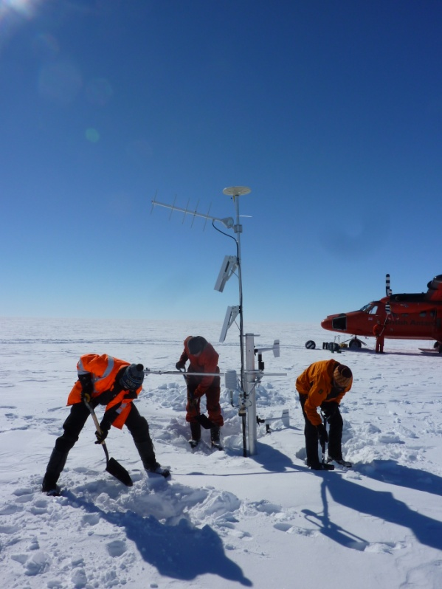

Photographs: site on arrival.

**Visual inspection**: The lower propvane was partially buried. The gold foil on the lower sonic ranger was visibly damaged.

**Procedure**: Dug down to logger box and first battery box. Battery box was raised to surface. Logger data was downloaded from CR10X (this took about 90minutes). The cable supplied for the Trimble R7 receiver did not fit the receiver unit so it was not possible to download the data or reprogram the receiver. The damaged sonic ranger head was replaced. Continued digging to retrieve the second battery box but finally gave up as it clearly had not been raised on the last visit and the hole was already 3m deep. The cable to the second battery box was extended to enable the raise. While digging a power cable with two stripped wire ends were found. They were still connected into the logger. This cable was pulled out and discarded. The mast was raised with ease. GOES antenna aligned. The hole was backfilled. Cables and instruments checked and tided. Battery box positioned against to the mast, to the east of the mast, below the propvanes. It was left half below the surface with snow piled on top.

**Recommendations**: A new battery box and batteries will be needed for the next raise (or more cable and connectors to extend further). A cable for the Trimble R7 receiver is needed.

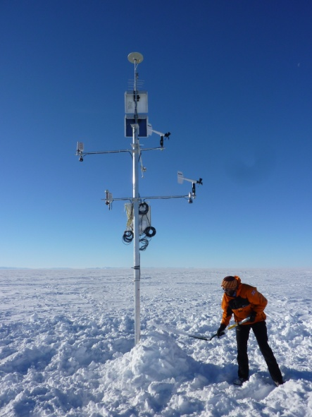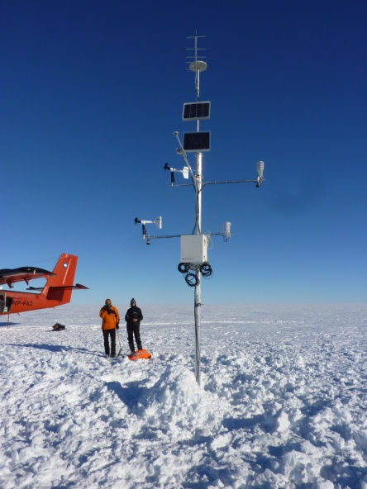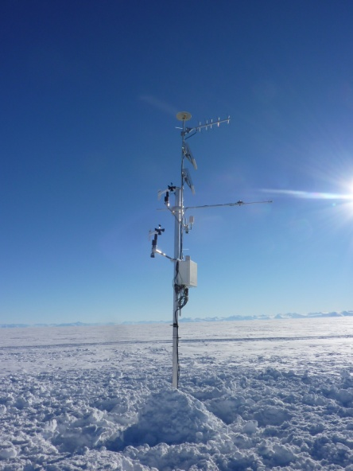

Photographs: site after raise with battery box under pile of snow.